| **Project Case** |  |
| --- | --- |
| COMP7084001  Multimedia Systems |
| Even Semester Year 2021/2022 |

* **Project Title**

JP KEYBOARD

* **Introduction**

APLIKASI PEMBELIAN KEYBOARD DAN AKSESORIS KEYBOARD MENGGUNAKAN ADOBE ANIMATE

* **Report / Documentation**

**CARA PEMAKAIAN PRODUK:**

**Melakukan klik di tombol product untuk melihat semua produk keyboard dan accesories, dan menekan tombol about us untuk melihat video dan informasi lainnya.**

1. 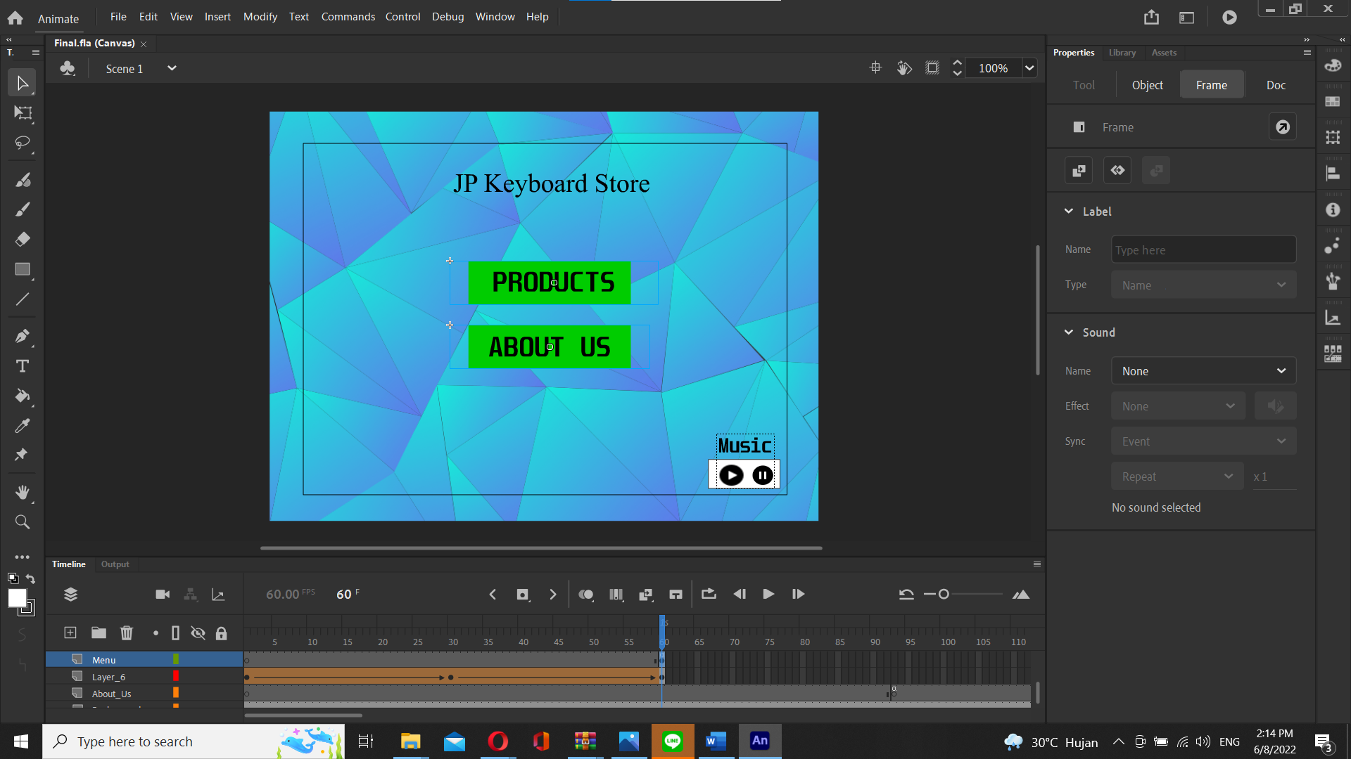

Pembuatan Main Menu

1. 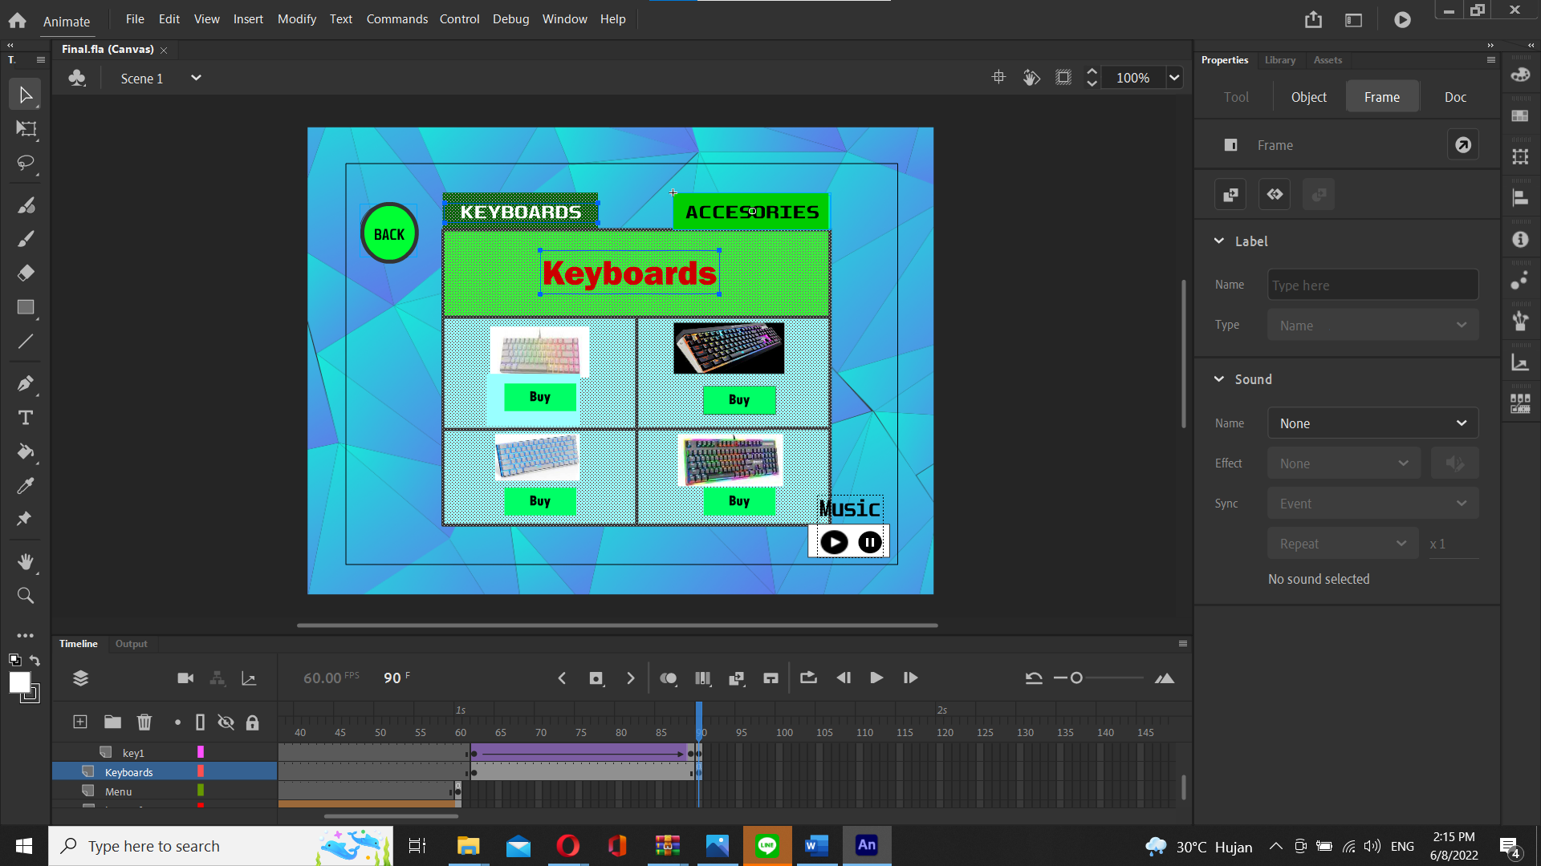

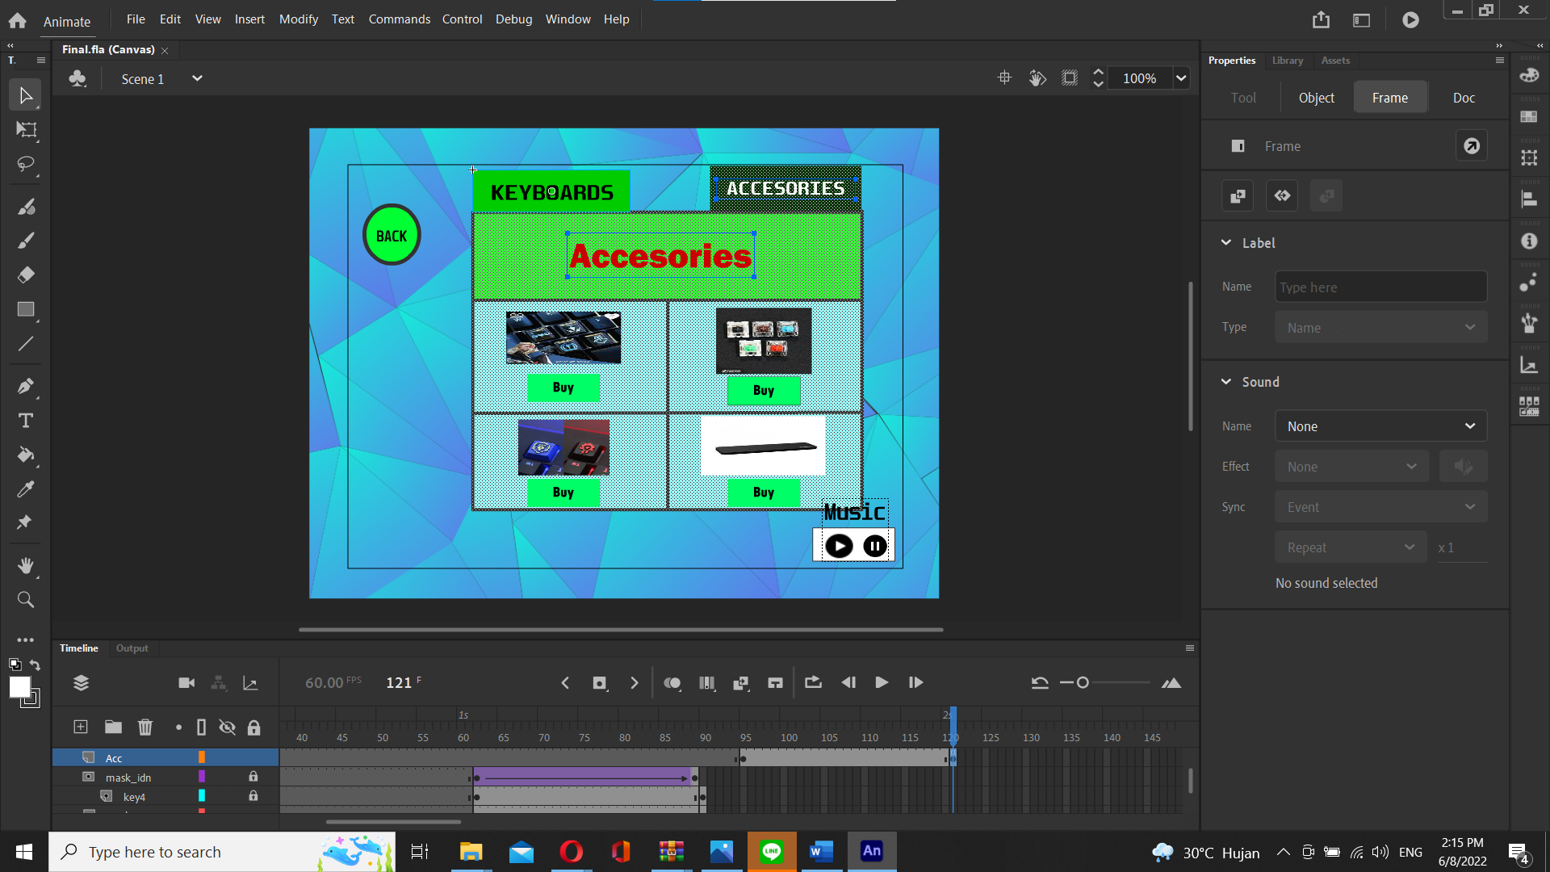

Pembuatan Halaman Produk

1. 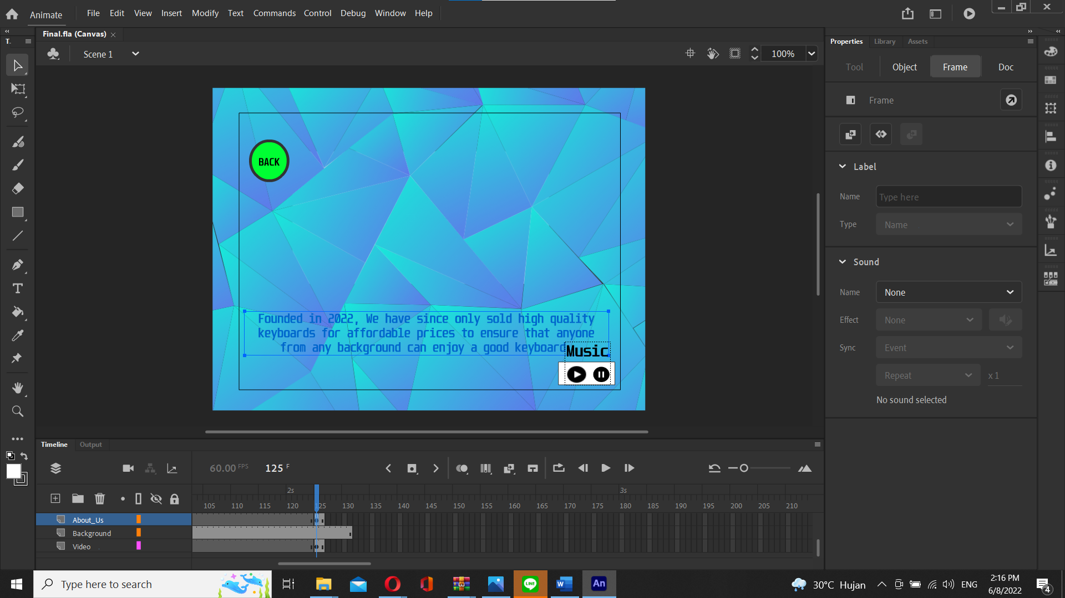

Pembuatan halaman About Us

* **Reference**
* <https://youtu.be/6XMNPW4K_5Q>
* <https://binusianorg-my.sharepoint.com/personal/slc_binus_edu/_layouts/15/onedrive.aspx?id=%2Fpersonal%2Fslc_binus_edu%2FDocuments%2FVBL%2FCOMP7084%20-%20Multimedia%20Systems%2FSession%2001&ga=1>
* <https://binusianorg-my.sharepoint.com/personal/slc_binus_edu/_layouts/15/onedrive.aspx?id=%2Fpersonal%2Fslc_binus_edu%2FDocuments%2FVBL%2FCOMP7084%20-%20Multimedia%20Systems%2FSession%2002&ga=1>
* <https://binusianorg-my.sharepoint.com/personal/slc_binus_edu/_layouts/15/onedrive.aspx?id=%2Fpersonal%2Fslc_binus_edu%2FDocuments%2FVBL%2FCOMP7084%20-%20Multimedia%20Systems%2FSession%2003&ga=1>
* **Group Member**
* 2440031250 - Jeremy Ardhito Sulle
* 2440032953 – Joshua Immanuel Tjandra
* 2401860092– Samuel Chandra